
Introduction to DOSBox
Lab 1

Computer Organization and Assembly Language

Student Name | Muhammad Hassan Khalid
Registration # | 21L-5692
Instructor | Hazoor Ahmad
Class | CS3
Section | A1, A2, D1, D2
Semester | Fall 2022

Fast School of Computing
FAST-NU, Lahore, Pakistan

Activity 1

Assembly Language Code
[org 0x0100]

jmp start

String1: db "Mr. Ali, Usman, & Anwar! Doing what???? want to travel????", 0
String2: db "", 0

clrscr: push es
push ax
push cx
push di

mov ax, 0xb800
mov es, ax
xor di, di
mov ax, 0x0720
mov cx, 2000

cld
rep stosw

pop di
pop cx
pop ax
pop es
ret

printstr: push bp
mov bp, sp
push es
push ax
push cx
push si
push di
push ds
pop es ; load ds in es
mov di, [bp+4] ; point di to string
mov cx, 0xffff ; load maximum number in cx
xor al, al ; load a zero in al
repne scasb ; find zero in the string
mov ax, 0xffff ; load maximum number in ax
sub ax, cx ; find change in cx
dec ax ; exclude null from length
jz exit ; no printing if string is empty
mov cx, ax ; load string length in cx
mov ax, 0xb800
mov es, ax ; point es to video base
mov al, 80 ; load al with columns per row
mul byte [bp+8] ; multiply with y position
add ax, [bp+10] ; add x position
shl ax, 1 ; turn into byte offset
mov di,ax ; point di to required location
mov si, [bp+4] ; point si to string
mov ah, [bp+6] ; load attribute in ah
cld ; auto increment mode
nextchar: lodsb ; load next char in al
stosw ; print char/attribute pair
loop nextchar ; repeat for the whole string
exit: pop di
pop si
pop cx
pop ax
pop es
pop bp
ret 8

Remove:mov bx, String1
xor si, si
xor di, di
l1: mov ax, [bx+si]
add si, 2
cmp ax, 0x2E ; removing period
je l1
cmp ax, 0x2C ; removing comma
je l1
cmp ax, 0x3F ; removing question marks
je l1
cmp ax, 0x21 ; removing exclamation marks\
je l1
cmp ax, 0x26 ; removing &
je l1
cmp ax, 0x20 ; removing Spaces
je l1
push bx
mov bx, String2
mov [bx+di], ax
pop bx
add di, 2
jmp l1
ret

start: call clrscr

call Remove

mov ax, 10
push ax ; push x position
mov ax, 15
push ax ; push y position
mov ax, 1 ; blue on black attribute
push ax ; push attribute
mov ax, String1
push ax ; push address of message
call printstr ; call the printstr subroutine

mov ax, 30
push ax ; push x position
mov ax, 20
push ax ; push y position
mov ax, 1 ; blue on black attribute
push ax ; push attribute
mov ax, String2
push ax ; push address of message
call printstr ; call the printstr subroutine

mov ax, 0x4c00
int 0x21

Debugging Screenshots
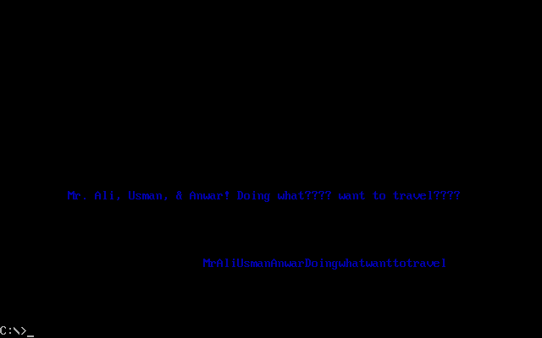

Activity 2

Assembly Language Code
[[org 0x0100]

jmp start

String1: db "I am Mr X", 0
String2: db "", 0
len : db 9

clrscr: push es
push ax
push cx
push di

mov ax, 0xb800
mov es, ax
xor di, di
mov ax, 0x0720
mov cx, 2000

cld
rep stosw

pop di
pop cx
pop ax
pop es
ret

printstr: push bp
mov bp, sp
push es
push ax
push cx
push si
push di
push ds
pop es ; load ds in es
mov di, [bp+4] ; point di to string
mov cx, 0xffff ; load maximum number in cx
xor al, al ; load a zero in al
repne scasb ; find zero in the string
mov ax, 0xffff ; load maximum number in ax
sub ax, cx ; find change in cx
dec ax ; exclude null from length
jz exit ; no printing if string is empty
mov cx, ax ; load string length in cx
mov ax, 0xb800
mov es, ax ; point es to video base
mov al, 80 ; load al with columns per row
mul byte [bp+8] ; multiply with y position
add ax, [bp+10] ; add x position
shl ax, 1 ; turn into byte offset
mov di,ax ; point di to required location
mov si, [bp+4] ; point si to string
mov ah, [bp+6] ; load attribute in ah
cld ; auto increment mode
nextchar: lodsb ; load next char in al
stosw ; print char/attribute pair
loop nextchar ; repeat for the whole string
exit: pop di
pop si
pop cx
pop ax
pop es
pop bp
ret 8

Reverse:
mov si, String1
mov di, String2
mov cx, [len]
add di,cx
dec di
push ds
pop es
cld
next:
movsb
sub di,2
loop next
ret

start: call clrscr

call Reverse
mov ax, 10
push ax ; push x position
mov ax, 15
push ax ; push y position
mov ax, 1 ; blue on black attribute
push ax ; push attribute
mov ax, String1
push ax ; push address of message
call printstr ; call the printstr subroutine

mov ax, 30
push ax ; push x position
mov ax, 20
push ax ; push y position
mov ax, 1 ; blue on black attribute
push ax ; push attribute
mov ax, String2
push ax ; push address of message
call printstr ; call the printstr subroutine

mov ax, 0x4c00
int 0x21

Debugging Screenshots
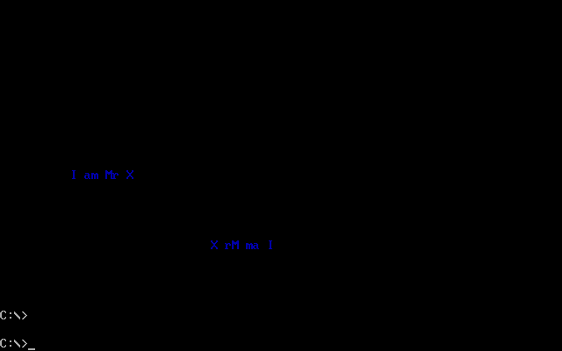

Activity 3

Assembly Language Code
[

[org 0x0100]

jmp start

String1: db "A man, a plan, a canal, Panama!!!", 0
String2: db "", 0
String3: db "", 0
String4: db "", 0
len : db 20

clrscr: push es
push ax
push cx
push di

mov ax, 0xb800
mov es, ax
xor di, di
mov ax, 0x0720
mov cx, 2000

cld
rep stosw

pop di
pop cx
pop ax
pop es
ret

printstr: push bp
mov bp, sp
push es
push ax
push cx
push si
push di
push ds
pop es ; load ds in es
mov di, [bp+4] ; point di to string
mov cx, 0xffff ; load maximum number in cx
xor al, al ; load a zero in al
repne scasb ; find zero in the string
mov ax, 0xffff ; load maximum number in ax
sub ax, cx ; find change in cx
dec ax ; exclude null from length
jz exit ; no printing if string is empty
mov cx, ax ; load string length in cx
mov ax, 0xb800
mov es, ax ; point es to video base
mov al, 80 ; load al with columns per row
mul byte [bp+8] ; multiply with y position
add ax, [bp+10] ; add x position
shl ax, 1 ; turn into byte offset
mov di,ax ; point di to required location
mov si, [bp+4] ; point si to string
mov ah, [bp+6] ; load attribute in ah
cld ; auto increment mode
nextchar: lodsb ; load next char in al
stosw ; print char/attribute pair
loop nextchar ; repeat for the whole string
exit: pop di
pop si
pop cx
pop ax
pop es
pop bp
ret 8

Reverse:
mov si, String1
mov di, String2
mov cx, [len]
add di,cx
dec di
push ds
pop es
cld
next:
movsb
sub di,2
loop next
ret

Reverse1:
mov si, String3
mov di, String4
mov cx, [len]
add di,cx
dec di
push ds
pop es
cld
next:
movsb
sub di,2
loop next
ret

Remove:mov bx, String2
xor si, si
xor di, di
l1: mov ax, [bx+si]
add si, 2
cmp ax, 0x2E ; removing period
je l1
cmp ax, 0x2C ; removing comma
je l1
cmp ax, 0x3F ; removing question marks
je l1
cmp ax, 0x21 ; removing exclamation marks\
je l1
cmp ax, 0x26 ; removing &
je l1
cmp ax, 0x20 ; removing Spaces
je l1
push bx
mov bx, String3
mov [bx+di], ax
pop bx
add di, 2
jmp l1
ret

strcmp: push bp
mov bp,sp
push cx
push si
push di
push es
push ds
lds si, [bp+4] ; point ds:si to first string
les di, [bp+8] ; point es:di to second string
push ds ; push segment of first string
push si ; push offset of first string
call strlen ; calculate string length
mov cx, ax ; save length in cx
push es ; push segment of second string
push di ; push offset of second string
call strlen ; calculate string length
cmp cx, ax ; compare length of both strings
jne exitfalse ; return 0 if they are unequal
mov ax, 1 ; store 1 in ax to be returned
repe cmpsb ; compare both strings
jcxz exitsimple ; are they palindrome
exitfalse: mov ax, 0 ; store 0 to mark not palindrome
exitsimple: pop ds
pop es
pop di
pop si
pop cx
pop bp
ret 8

start: call clrscr

call Reverse
call Remove
call Reverse1

push ds ; push segment of first string
mov ax, String2
push ax ; push offset of first string
push ds ; push segment of second string
mov ax, String4
push ax ; push offset of second string
call strcmp ; call strcmp subroutine

mov ax, 10
push ax ; push x position
mov ax, 15
push ax ; push y position
mov ax, 1 ; blue on black attribute
push ax ; push attribute
mov ax, String1
push ax ; push address of message
call printstr ; call the printstr subroutine

mov ax, 30
push ax ; push x position
mov ax, 20
push ax ; push y position
mov ax, 1 ; blue on black attribute
push ax ; push attribute
mov ax, String2
push ax ; push address of message
call printstr ; call the printstr subroutine

mov ax, 40
push ax ; push x position
mov ax, 5
push ax ; push y position
mov ax, 1 ; blue on black attribute
push ax ; push attribute
mov ax, String2
push ax ; push address of message
call printstr ; call the printstr subroutine

mov ax, 0x4c00
int 0x21

Debugging Screenshots

